Chaperone Polo Order Form
These polo shirts are just like the ones that the band students wear except they are gold with white trim. The Band logo will be embroidered on one side and then you can have up to 3 lines of print on the other side. The cost of the Polo is $37.oo. We will accept cash and checks, please make checks payable to MHSBPA.
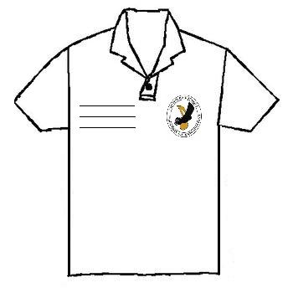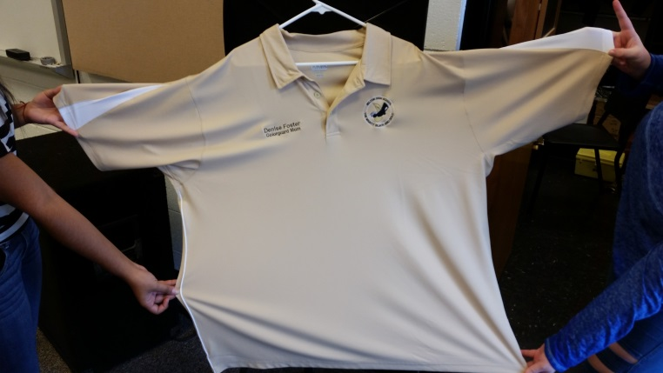
Check one
Men’s – Small____ Medium____ Large____ XL____ 2X____ 3X_____
Ladies- Small_____ Medium____ Large____ XL____
Please indicate what you want embroidered on the shirt up to 3 lines

Name:________________________________________
______________________________________________
______________________________________________

